Programming Assignment 3:

Error Detection and Correction

I put together some notes which might suggest one possible algorithm for calculating Hamming Code check (parity) bits.

Consider the chart below.

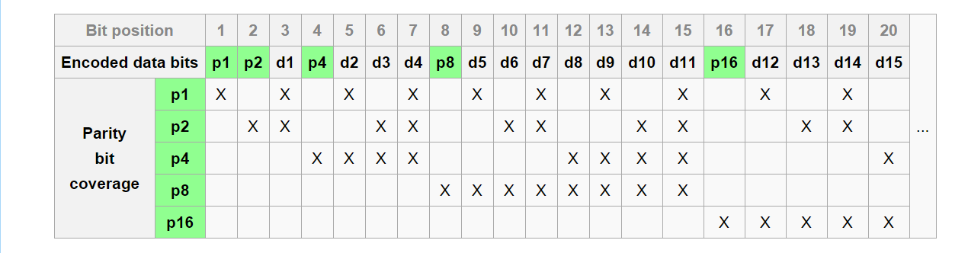

**You might want to think in terms of three nested for- loops.**

1. The index for the outer most loop might be related to the parity bit position, starting with p1 in position 1. Similarly, p4 starts with position 4. An question worth asking yourself is, “How does this index increase each time through the outer loop?”
2. The index for the second loop might be the starting position of a series of group of bits associated with the current parity bit. That is, it begins equal to the current index of the outer loop (which keeps increasing each time through the outer loop).

So, when computing p1, this index begins at position 1, and when computing p2, this index starts at position 2. What value does it begin with for p4, p8, etc.? How does it increase each time though this loop?

1. The index for the third, inner most loop controls how many consecutive bits are included in each group.

For example, when computing p2, this index goes up to 2 in each group. When computing p8, eight consecutive bits are involved (i.e. p8, d5…d11)

1. All of the indices of the three for-loops are limited by the length of the input string and other conditions.

Good luck with the assignment. Start it now!